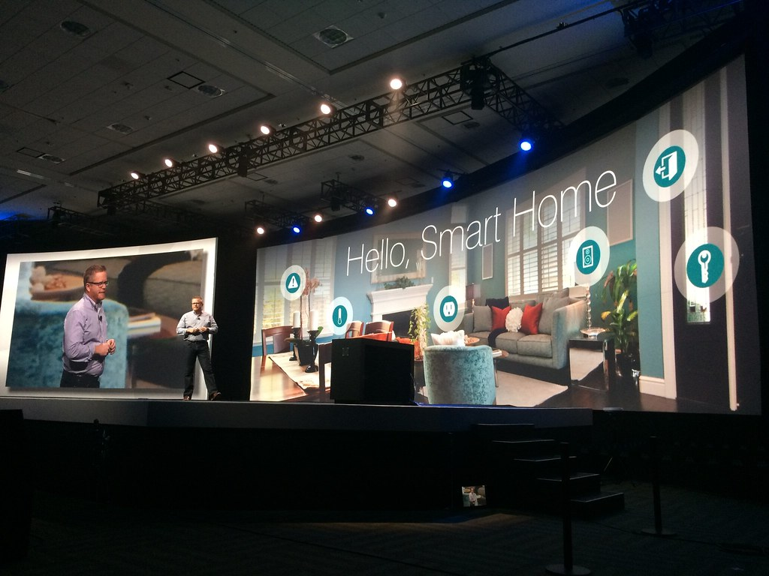

Project Name:

Sentinel: Smart Home Security and Monitoring System

  - Prepared By:
  - Mohammad Murra

Components Used in My Smart Home Project:
Electrical Components:
- Servo Motors (Qty: 2)
- LEDs (Qty: 4):
2 Red LEDs
1 Green LED
1 Blue LED

- RFID Card with Reader
- Push Button
- Resistors (Qty: 5):
4 x 330 Ohm
1 x 1K Ohm
- LCD 16x2 I2C
- Flame Sensor
- Gas Sensor (MQ5)
Home Design Components:
- Foam Boards (Qty: 2)
- Wooden Shish
- Papers
- Sliding Bolt Lock
- Door Hinges (Qty: 2)
Software:
Arduino IDE

